*Case Study 1.4:* ***Importance of having proper BT connections, notably after a meal started*** V.3

Here an incidence report that emphasizes the high importance of having proper Bluetooth connectivity with the pump (and with the CGM), notably after starting a meal.

**Glucose going higher than usual after starting a meal**

After a ~12:30 h lunch, I saw glucose rise, by 13:40 h, to about 230 mg/dl, which is an unusually high level for me.

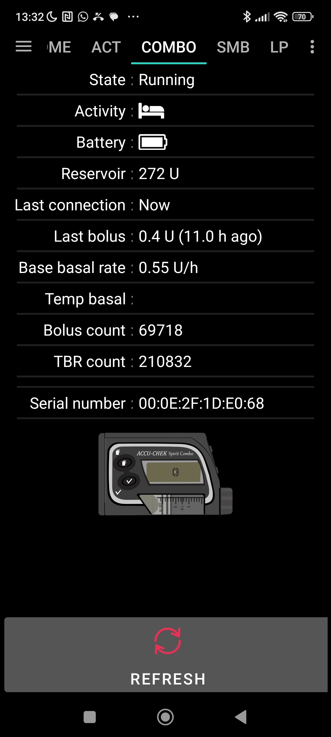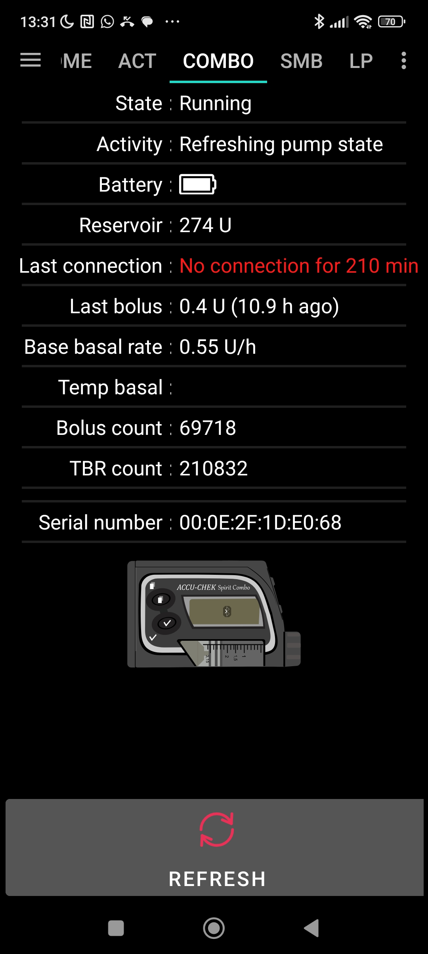My AAPS home screen (graph 1) reveals a super low iob (0.01 U) and the yellow insulin activity curve seems missing. Also, there are no blue triangles from SMBs. Nearly no insulin had been given despite glucose rising sharply to over 200 mg/dl:

2

3

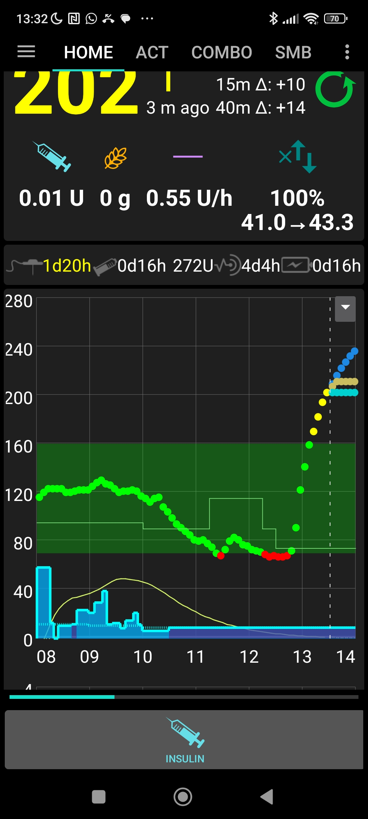

1

The dark blue block (instead of jittery TBR curve) for basal hinted at a pump problem, which I could confirm looking into the pump tab (graph 2).

By pressing Bluetooth on my pump, and “refresh” at the bottom of the pump tab in AAPS, the pump connection could immediately be re-established (graph 3).

**Catching up with iob after pump re-connection**

Upon the next received CGM value, AAPS triggered a SMB again (graph 4).

The SMB size was surprisingly low, though. Graphs 4 – 7 show why that is:

6

5

4

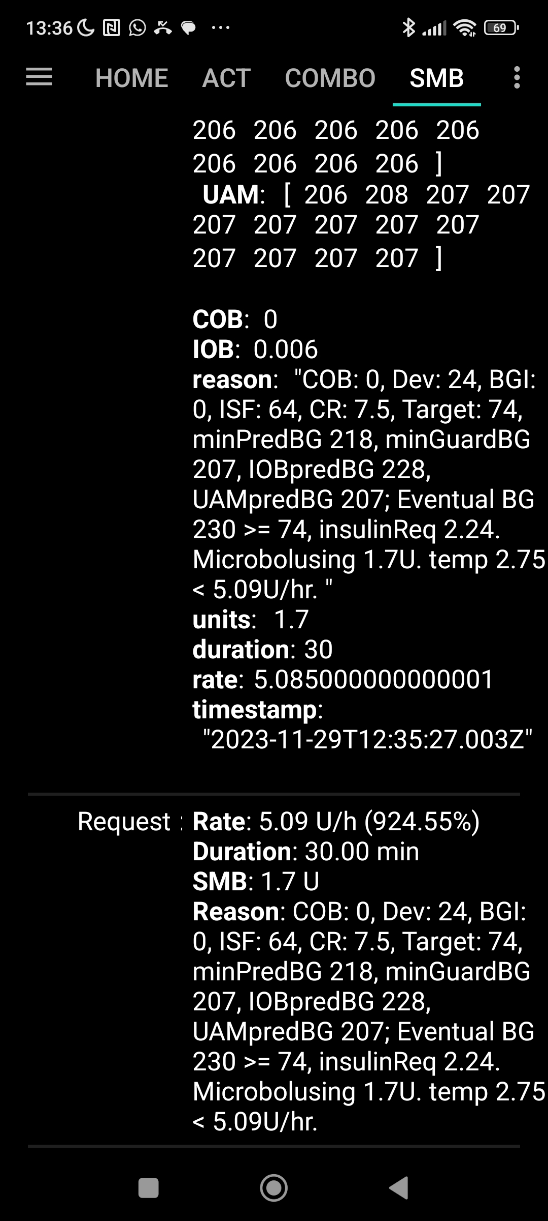

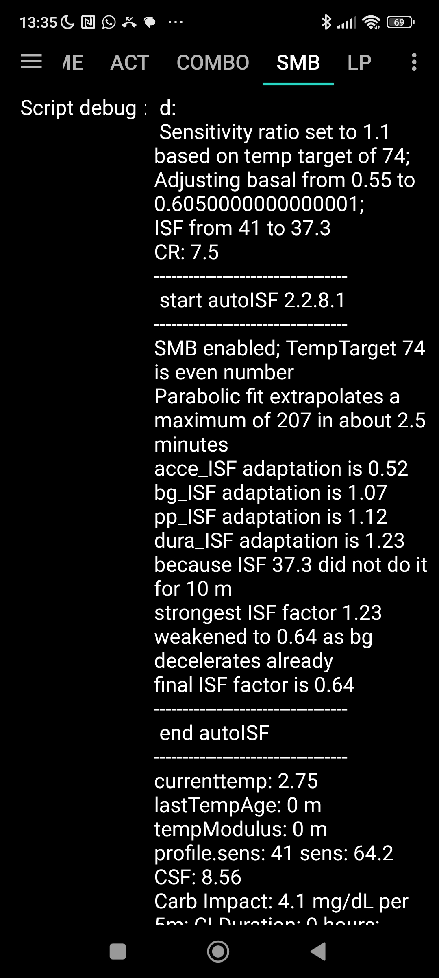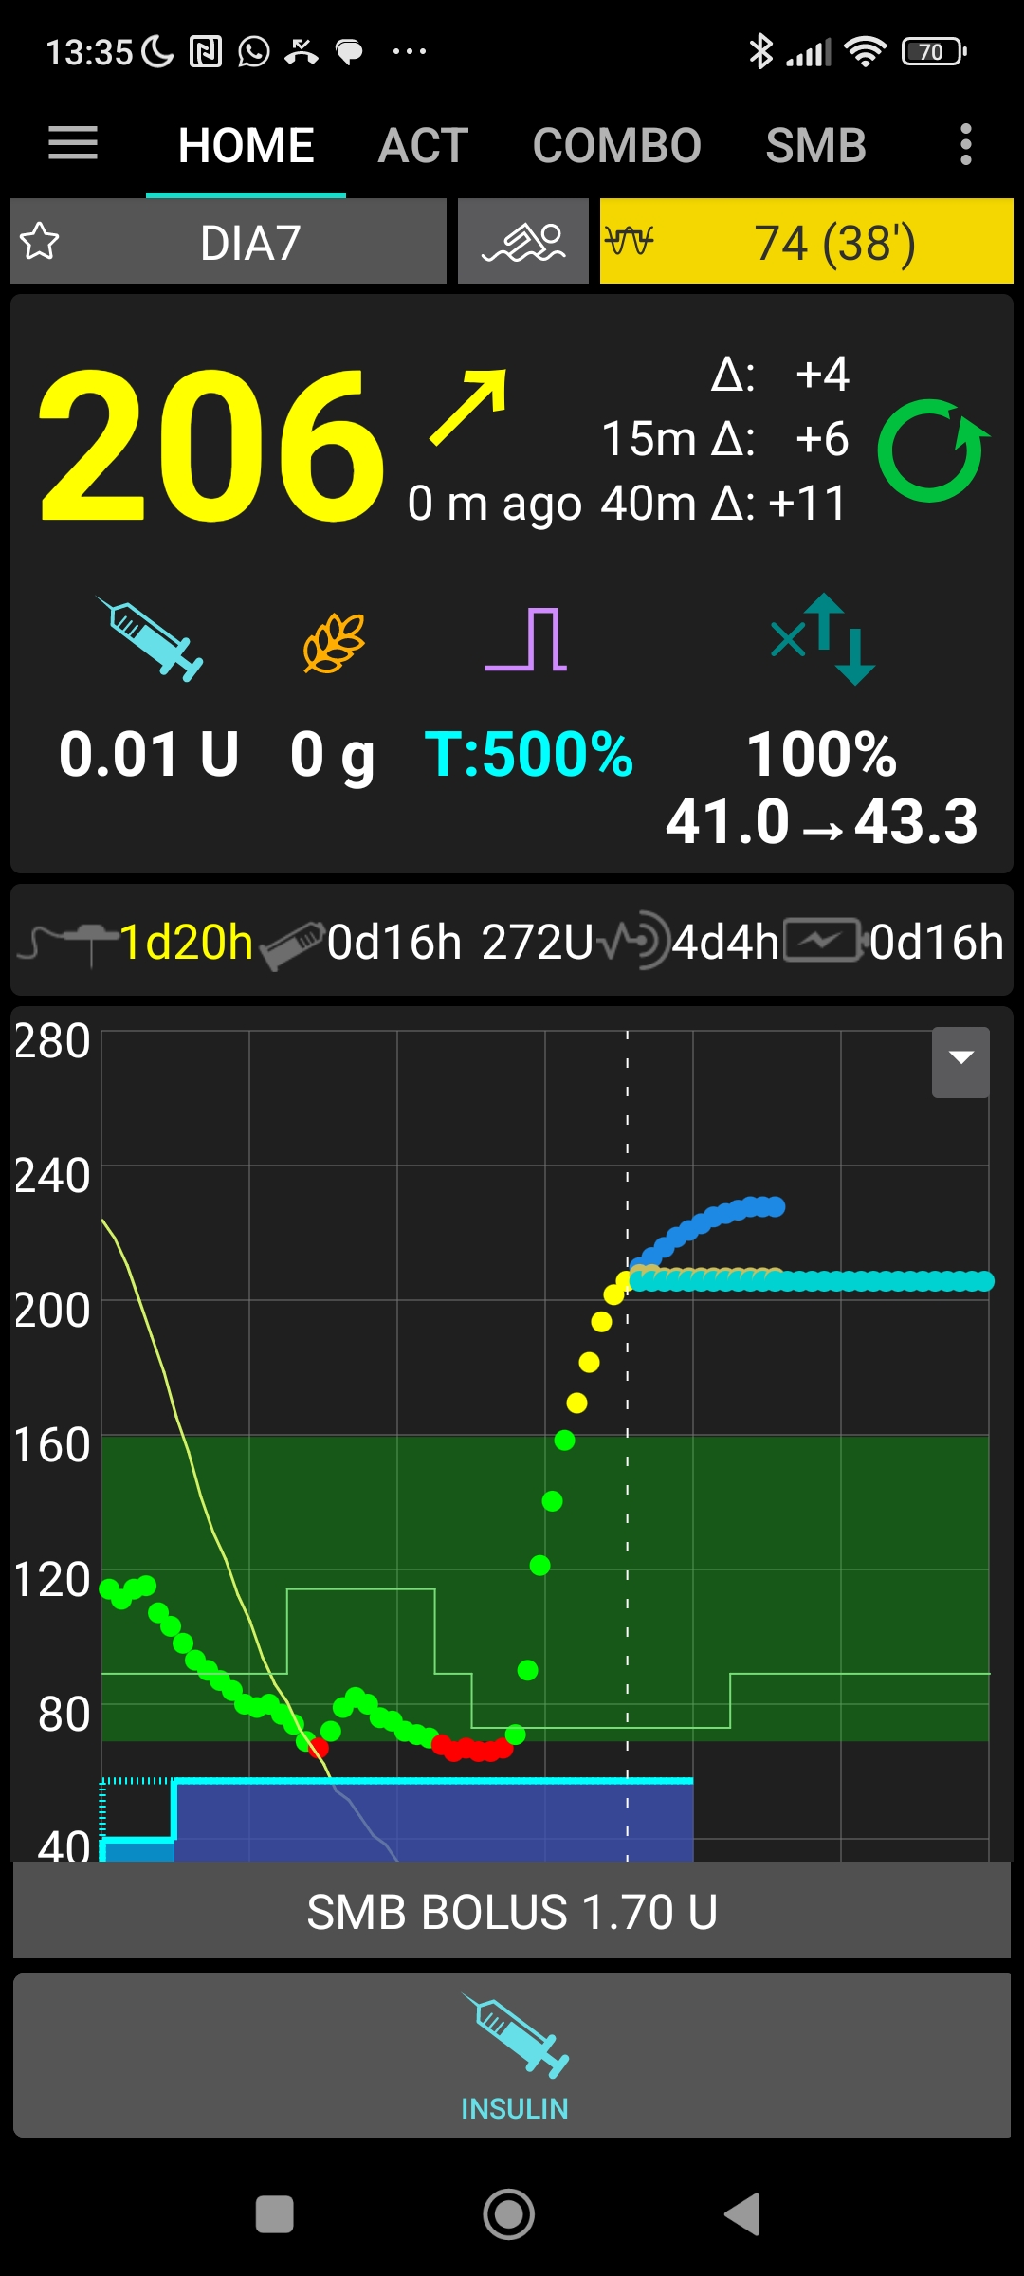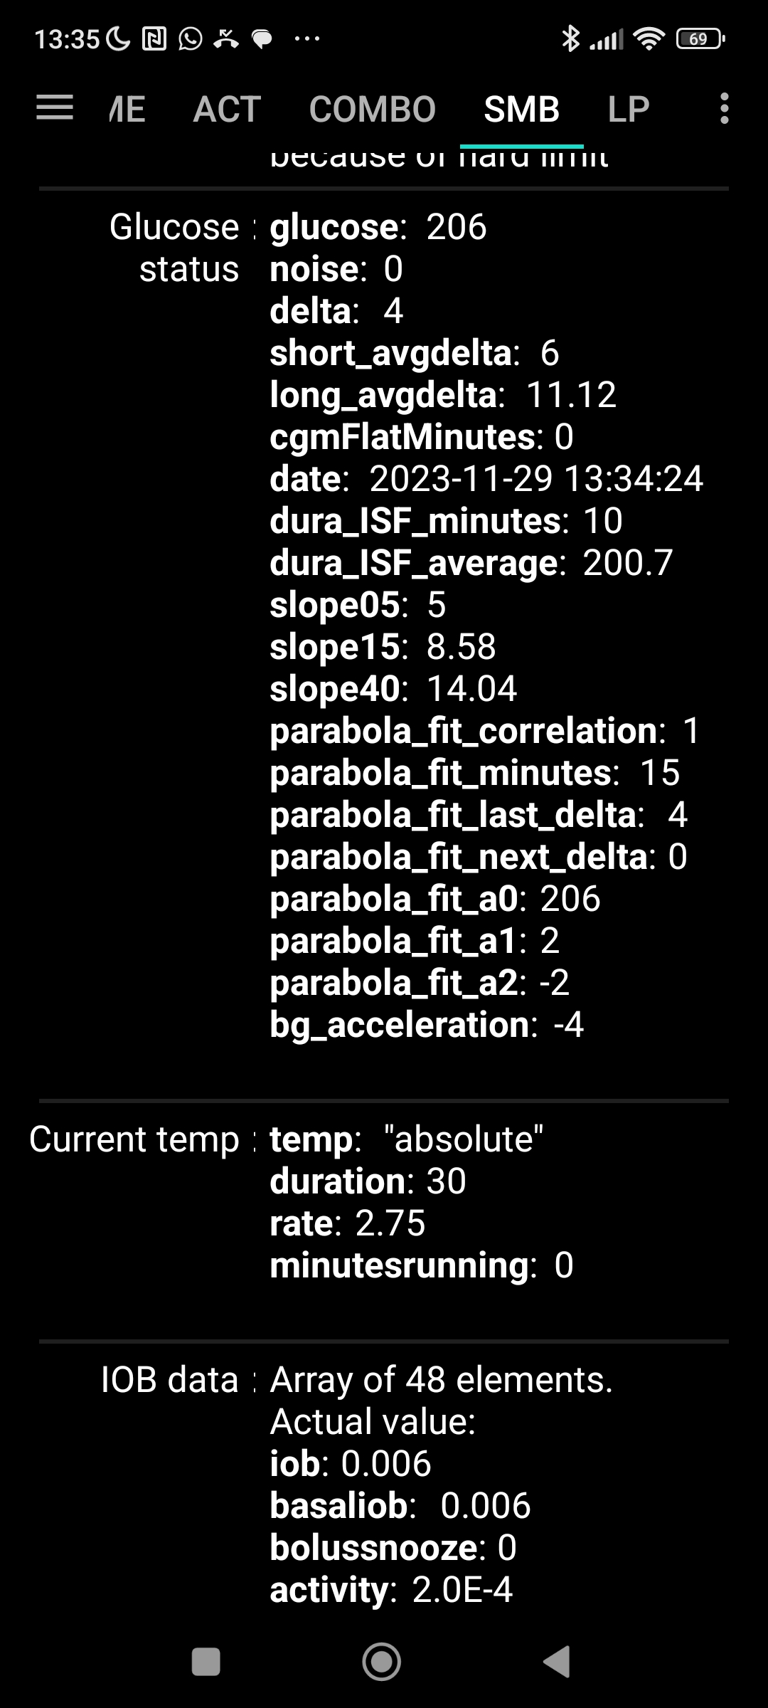

FCL was essentially off during the acceleration and steep rise phase. When BT with the pump was finally re-established, this was in a phase of already de-celerating bg ( - 4, see graph 5), and hence very weak ISF (graph 6: 1,24 -> 0.64 factor) to be applied.

Foreseeably, every 5 minutes another moderate size SMB would have been devised. But as so much time was already lost, and high peak over 200 already reached, it seemed

7

indicated to briefly leave the FCL mode, install an insulin button (bottom of graph 4), and manually bolus (4.2 U on top of the 1st SMB of 1.70 U, graph 9) to immediately reach an iob as I need for such meals.

Still , iob is not active insulin, and 15-20 minutes further rising bg was to be expected before seeing the effect of the insulin in breaking the upwards trend in bg (graph 8).

The meal had been such that 2 solid hours (~ 13 to 15 h), worth of 30 g max carb absorption each, had to be expected. Therefore, about 45 minutes after my given 4.2 U bolus, the glucose curve turned a bit upwards again. Based on the detected significant acceleration, autoISF finally was in a position to issue a significant SMB of 3.2 U at 14:20 (02.20 PM). Graphs 8 and 9 show that this SMB at 02:20PM was important to get glucose back into range.

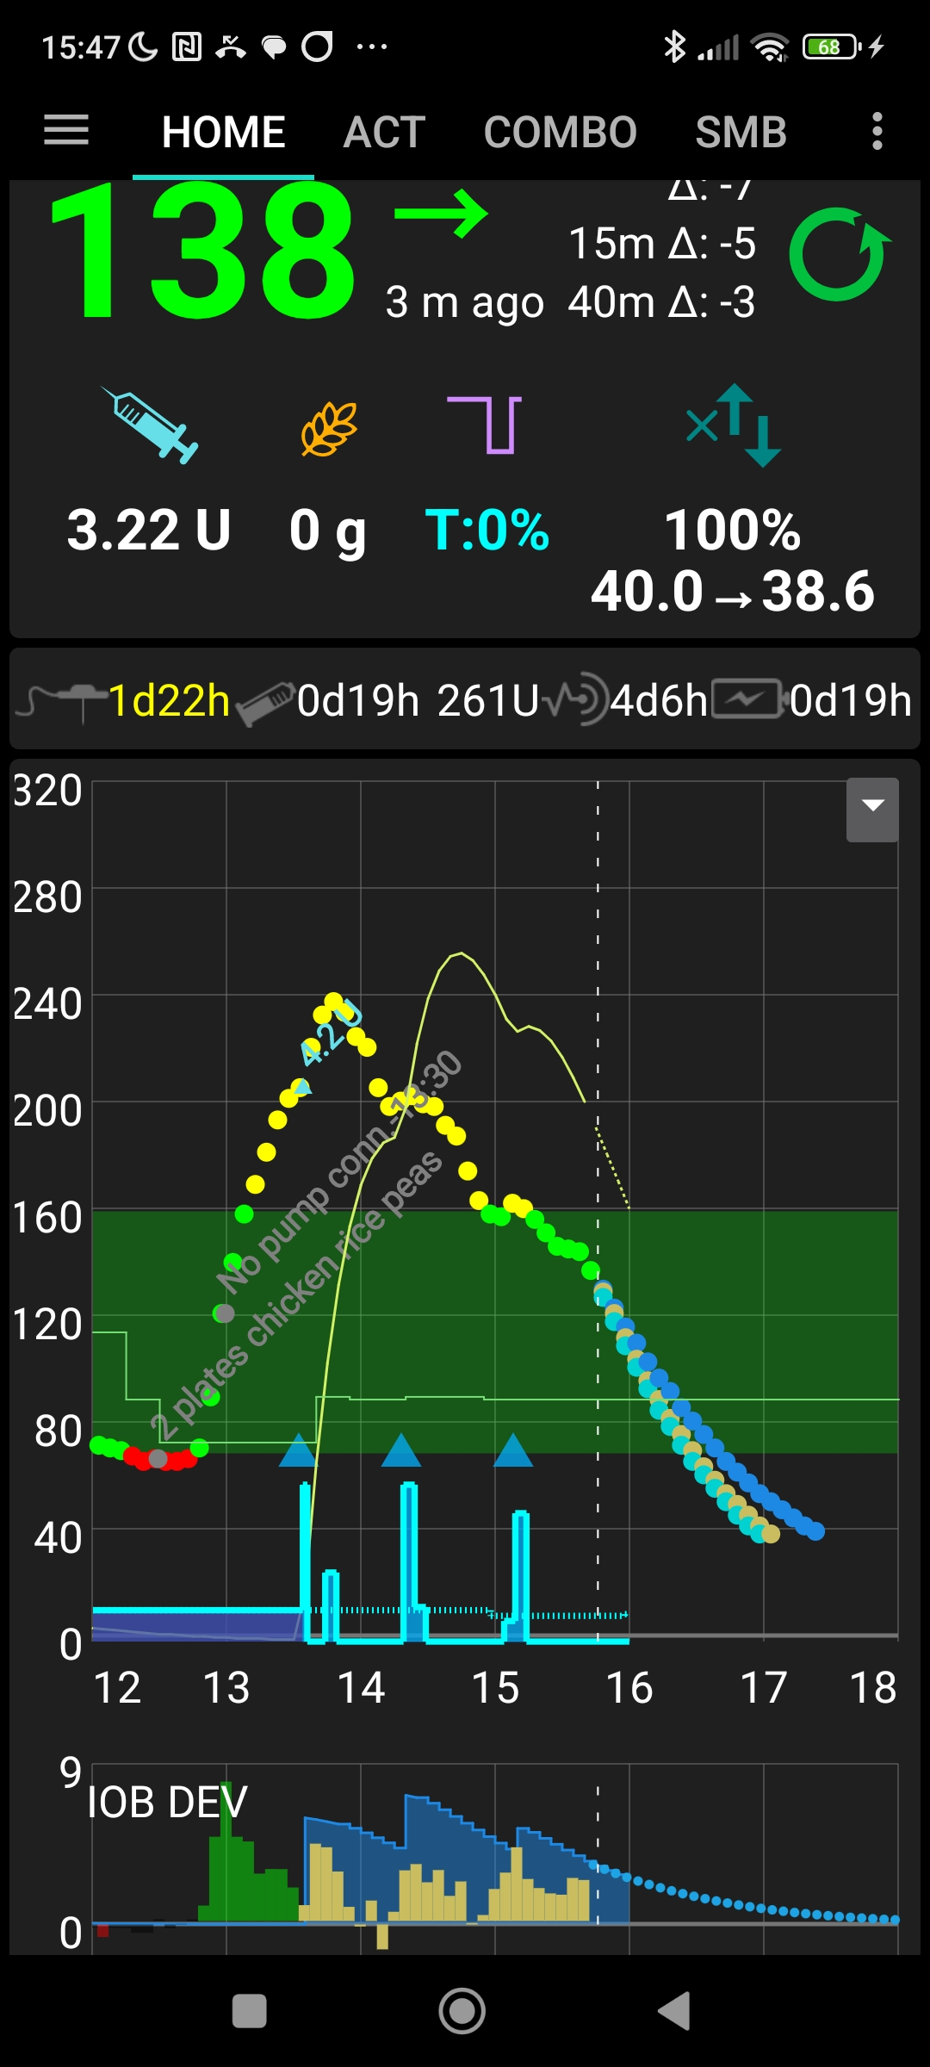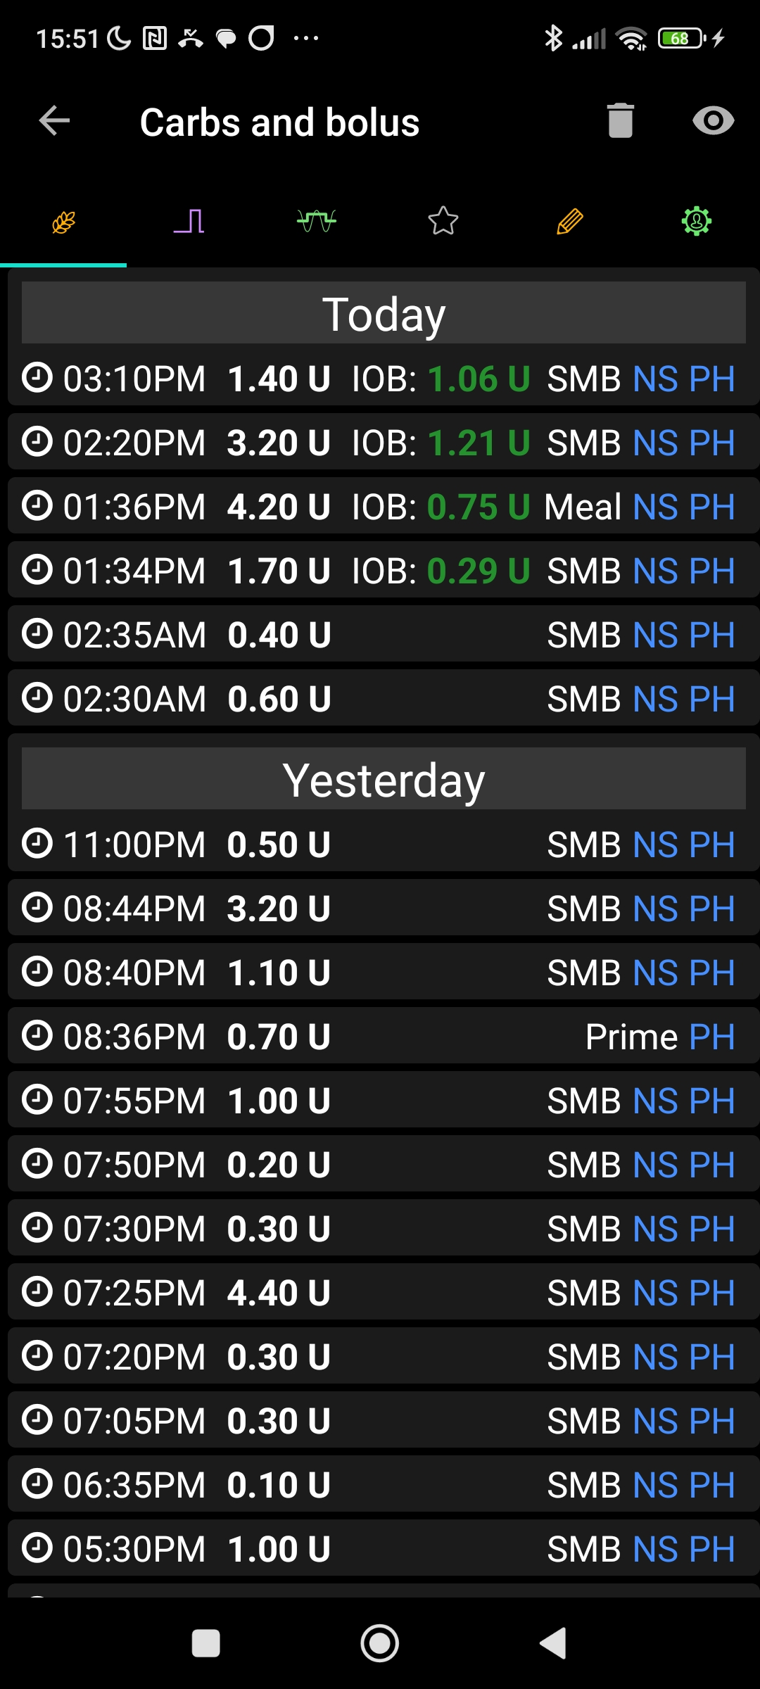

**8 9**

9

8

**Conclusions**

A no-bolus FCL absolutely requires intact pump connection, notably in the hour after any meal start.

Same of course applies to needing un-interrupted glucose values. But these are less likely to go unnoticed for a while, because lacking glucose values are easy recognized from just glancing on screen or watch occasionally.

autoISF „designs“ SMB response to be aggressive only when acceleration and big glucose deltas are seen. However, this phase might be missed while the pump had lost connection to AAPS (and gave only basal).

Upon re-connecting, the loop response might be significantly weakend by falling into a de-celerating phase of the bg curve.

In this situation, to issue a user bolus (and immediatley after to go into FCL again) can help get back on track (into range) faster.

*Avoid* giving a bolus *just under* the valid iobTH, though: Your relative big „user bolus“ will, even with Lyumjev, take a couple of minutes to have any effect. So, in the meantime, you probably will see further bg rise, with a chance that a fairly big additional SMB might be triggered by the loop and significantly surpass iobTH.

Avenues to avoid the problem could be:

* It is probably worth defining an alarm for lost connectivity to the pump during daytime (at night, an on-going basal should be OK, too).

This could be done via an Automation: Conditions: Time between 07 and 22 h AND Last connection to pump greater than 12 min ago ACTION: Notification and/or Alarm

* A preferable alternative might be to make an alarm „safety“ setting in /Preferences (or Nighscout? ) *how exactly ?*
* An Automation could build also on the observation bg>140 and iob remained near zero …

NN / could add a lost CGM connection case